**CSE 402L: Digital Signal Processing**

|  |  |  |  |  |
| --- | --- | --- | --- | --- |
| **Demonstration of Concepts** | **Poor (Does not meet expectation (1))**  The student failed to demonstrate a clear understanding of the assignment concepts | **Fair (Meet Expectation (2-3))**  The student demonstrated a clear understanding of some of the assignment concepts | **Good (Exceeds Expectation (4-5)**  The student demonstrated a clear understanding of the assignment concepts | **Score**  **30%** |
| **Accuracy** | The student completed ( <50%) tasks and provided MATLAB code and/or Simulink models with errors. Outputs shown are not correct in form of graphs (no labels) and/or tables along with incorrect analysis or remarks. | The student completed partial tasks (50% - <90%) with accurate MATLAB code and/or Simulink models. Correct outputs are shown in form of graphs (without labels) and/or tables along with correct analysis or remarks. | The student completed all required tasks (90%-100%) with accurate MATLAB code and/or Simulink models. Correct outputs are shown in form of labeled graphs and/or tables along with correct analysis or remarks. | **30%** |
| **Following Directions** | The student clearly failed to follow the verbal and written instructions to successfully complete the lab | The student failed to follow the some of the verbal and written instructions to successfully complete all requirements of the lab | The student followed the verbal and written instructions to successfully complete requirements of the lab | **20%** |
| **Time Utilization** | The student failed to complete even part of the lab in the allotted amount of time | The student failed to complete the entire lab in the allotted amount of time | The student completed the lab in its entirety in the allotted amount of time | **20%** |

**MATLAB Training:**

**Problem a.**

Make sure that you understand the colon notation. Explain in words what the following MATLAB.

code will produce.

**Code :**

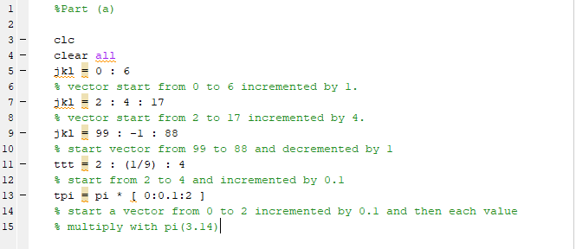

**Output:**

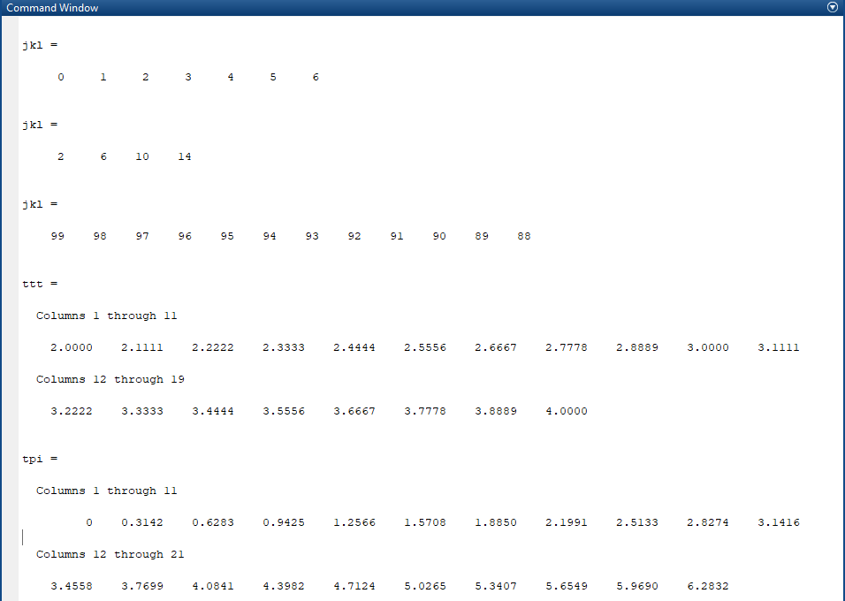

Problem b**:**

Extracting and/or inserting numbers into a vector is very easy to do. Consider the following definition of xx:

**Code :**

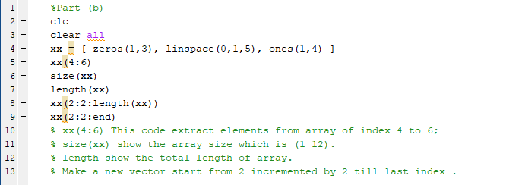

**Output:**

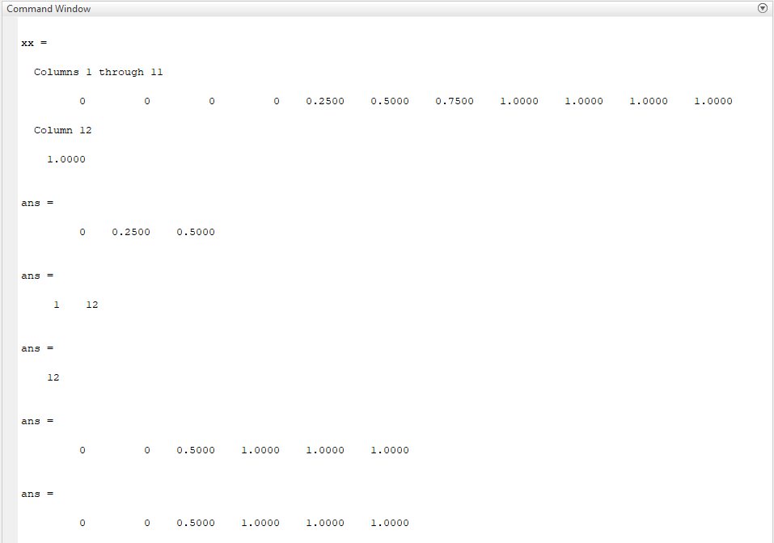

**2.2 MATLAB Script Files:**

**Problem a:**

**Code :**

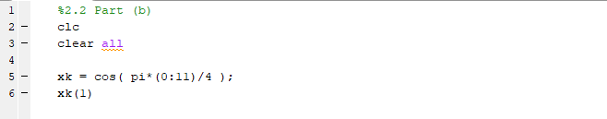

In matlab the array starts from 1 in matlab therefore it will give error.

**Problem b:**

**Code :**

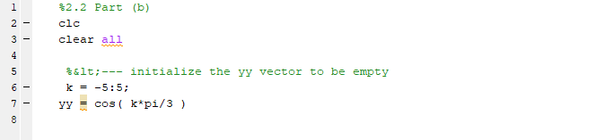

**Problem c:**

**Code :**

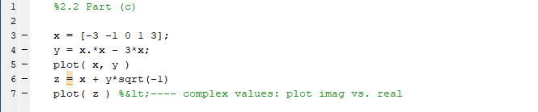

**Problem d:**

**Code :**

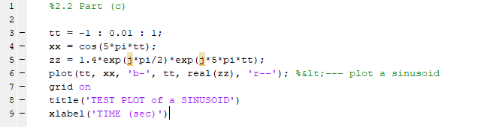

**Output:**

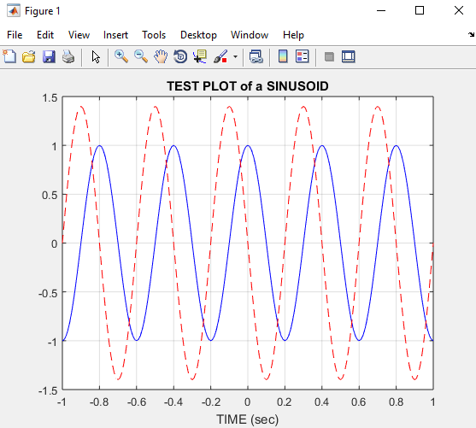

**2.3 MATLAB Sound:**

**Problem a:**

**Code :**

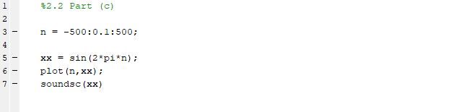

**Output:**

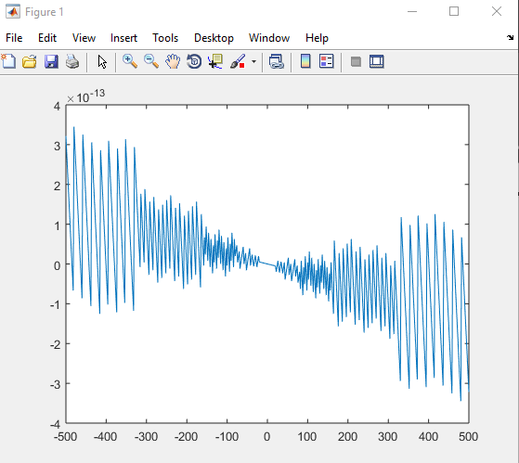

**2.3 MATLAB Sound:**

**Code :**

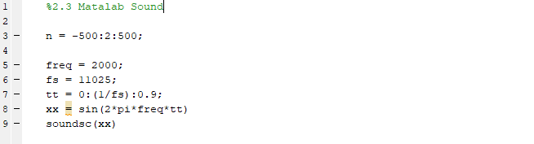

**Output:**

